**Describing and comparing all-cause mortality trends in Scotland with other high-income nations (1981-2017)**

Lynda Fentona 1 2, Jon Minton1, Julie Ramsay3, Maria Kaye3, Gerry McCartney1

1. Corresponding author: [lynda.fenton@nhs.net](mailto:lynda.fenton@nhs.net)
2. Public Health Observatory, NHS Health Scotland, 5 Cadogan Street, Glasgow, Scotland, G2 6QE.
3. Public Health, NHS Greater Glasgow and Clyde, West House, Gartnavel Royal Hospital Campus, 1055 Great Western Road, Glasgow, G12 0XH.
4. National Records of Scotland, Ladywell House, Ladywell Road, Edinburgh, Scotland, EH12 7TF.

**Abstract**

**Background**

Mortality rates have increased, and life expectancy decreased, in several high income countries over the last five years. This study aims to describe the nature, scale and timing of changes in mortality in Scotland, and to compare the trend to those seen internationally, as an early step in understanding the causes of the trends.

**Methods**

We used mortality data obtained from the Human Mortality Database (HMD) to calculate the mean annualised life expectancy change for 13 high income countries over five year periods between 1992 and 2016. For Scotland, we used mortality data from National Records of Scotland (NRS) to calculate the mean annual change in life expectancy for five year periods from 1857-2016, and then as part of a one- and two-break segmented regression model to estimate the turning point in age-standardised mortality trends between 1990 and 2018.

**Results**

Life expectancy in Scotland increased most quickly between 1892 and 1956 with some short periods of decline for men, and then with smaller and steadier increases from 1957 onwards. Between 2012 and 2016 the increases were only 2.5 weeks/year for women and 4.5 weeks for men. Of 13 high income countries, only England & Wales and the USA saw smaller increases than Scotland over this time period, but others such as Japan and Belarus experiencing large increases. In Scotland, the recent breakpoint in the mortality trends for all ages was best estimated for men in the year to Q2 2012 and for women in the year to Q4 2013.

**Conclusion**

Life expectancy improvement has stalled across many high income countries, but this is not ubiquitous. The recent change in the mortality trend in Scotland occurred between 2013 and 2014. Further research is required to understand these trends, but in the meantime governments should take action to ensure effective public services, incomes, health and social care services and influenza vaccination programmes are in place.

**Key Words**

Mortality, Life expectancy, Scotland, Europe, trend, austerity, influenza.

|  |
| --- |
| **Summary box** |
| **What we already know**   * Life expectancy improvements have stalled in many high income countries. * Influenza and austerity have been proposed as explanations for the changed trends. |
| **What this study adds**   * Amongst selected high income countries, improvements in life expectancy have stalled most in the USA, England & Wales, Scotland and the Netherlands. * The life expectancy trends are not ubiquitous, with some countries such as Belarus and Japan continuing to display improvements. * Mortality trends in Scotland changed between 2011 and 2016 to improve more slowly thereafter. |

**Background**

Mortality rates have steadily declined, and life expectancy at birth steadily improved, across most high income countries since 1945.[1] [2] There have been previous exceptions to this general trend, including the countries of Eastern Europe during the 1990s1 [3], and nations at war or with substantial civil conflict.[4] More recently there have been a series of reports that these trends are now faltering, or even worsening, for the USA, the UK and its constituent nations, and much of continental Europe, since around 2012.[5][6]-[7]

In addition to stalling of life expectancy gains, there have been increases in the absolute number of deaths occurring in recent years in UK countries, and a number of analyses have focused on the crude death counts observed in particular periods (for example increases seen in the winter 2014-2015). Timely monitoring of short-term fluctuations will necessarily depend on crude data, however adequate and appropriate age-standardisation is important for understanding the medium to long-term mortality trends. Contextualising current mortality trends within those that have been observed previously and internationally is an important step in determining proportionate public health actions.

International comparison of changes in life expectancy across a single year (2014 to 2015) found that of 18 high income countries, life expectancy fell by an average of 9 weeks for men and 11 for women, declining most in Italy, Belgium, Germany, France, the UK, Spain, the Netherlands and the USA; but increasing in Finland, Japan, Australia, Norway, Canada and Denmark.5 Countries with declining life expectancy generally had increased mortality in those aged >65 years and due to deaths from respiratory disease and cardiovascular disease. There was a different picture in the USA however, as mortality rose amongst younger adults due to external causes such as drug-related deaths.5 [8] However, the short-run trends in mortality rates and life expectancy, even at national level, can vary substantially from year to year and can be very sensitive to the comparison period.[9] Care is therefore required in describing the trends, when they may have changed, and in interpreting trends using emerging data which may be modelled or crude.8 [10]

Several hypotheses have been proposed to explain the changes in trends. It is possible that different factors are important for different populations, but it seems more likely that factor that are common to all of the countries displaying similar trends, and which is absent in countries without the change in trend, are causal.[11] It is also likely that several factors acting together are relevant to explaining the trends, whether that is some aspect of the context (such as underlying political economy within a country) or two specific factors interacting. Many of the hypotheses proposed thus far are not mutually exclusive, but that does not mean that they are all causal factors or carry the same importance.

Cohort effects, whereby a particular generation is found to be at higher risk of mortality, may be important if that generation is now reaching an age where it contributes more to the overall mortality and life expectancy statistics. Other possibilities are that there is an interaction between period effects (such as policy changes or infectious disease epidemics) and vulnerabilities within a cohort such that mortality for that group increases. This has been observed for specific causes of death in Scotland and the USA (for suicide, drug-related deaths and alcohol).[12][13][14]-[15]

Polarisation of the debate regarding causes of stalled life expectancy may not be helpful for supporting effective public health action to address it. Much of the apparent polarisation within the literature may be attributable to seeking the answers to different questions (for example causes of high numbers of deaths in short periods of time or stalling of overall life expectancy) and in the variable comparator, or baseline, periods employed. All of the studies proposing or investigating the change in trends have been limited to a degree by a lack of clarity on the timing, rapidity and degree of change in the trends – all factors that can help in causal investigation.11

Scotland has the lowest life expectancy of the UK countries, with a current period life expectancy at birth 2 years lower for women and 2.5 years lower for men than that observed in England (ref: NRS). Analysis by the ONS found that a slowdown in mortality rates has been seen in all four UK countries in 2011 to 2016 compared to 2006-2011, but that Scotland experienced the least stalling for women, and second least after Northern Ireland for men.7

This study aims to describe the nature, scale and timing of changes in mortality in Scotland, and to compare the trend to those seen internationally, as an early step in understanding the causes of the trends.

**Methods**

We report our results in accordance with the RECORD guideline.[16]

**Data sources**

We used civilian population data from the Human Mortality Database (HMD)[17] for all our analyses except for the segmented regression and decomposition analyses which used data held by National Records of Scotland (NRS). All analyses were undertaken for males and females separately. The annual data trends will be different from the published data using 3-yearly rolling averages. Where we have used annual or quarterly data, we have done so to provide the maximum number of data points to identify turning points in the trends. The data in this form are often not how they are presented by national statistics agencies because they are at risk of substantial random year-to-year variation. This variation should therefore be interpreted very cautiously.

**Life expectancy trends**

Period life expectancy trends for Scotland for each single year between 1855 and 2016 were extracted. For the international comparisons, data for all countries with a total population of >2million and with data available from 1992 to 2016 (inclusive) at the time of extraction were obtained via the HMD. The mean annual change in life expectancy (in weeks) for five year periods running back from 2016 were then calculated for each country. A sensitivity analysis using rolling five-year time periods rather than set periods from 2016 backwards was also undertaken.

**Segmented regression**

We calculated age-standardised mortality rates for each quarter of each year for Scotland using the 2013 European Standard Population for the entire time period (Q4 1990 to Q2 2018), and then created rolling trends which pooled the named quarter with the three previous quarters. In this way, quarter 1 (Q1) in 2016 pools the data for 2015 Q2-4 with 2016 Q1. Quarterly-rolling rates were calculated in order to increase the number of data points available to the model. We then undertook segmented regression in R using the ‘segmented’ package.[18] Two tests were run: the Davies test identifies the data point within the series that is the best fit breakpoint, and provides a test of the statistical significance of this; the ‘segmented’ test treats the whole time series as continuous and identifies the breakpoint to three decimal points, along with the standard error. The results of the segmented test were interpreted as identifying the quarterly data point within which the breakpoint fell. In this way a result of 2012.651 falls within quarter 3 of 2012, the data which correspond to this quarter actually represent the ‘year’ quarter 4 2011 to quarter 3 2012, hence this is interpreted as the breakpoint ‘year’. Ninety-five percent confidence intervals for the breakpoint were calculated from the standard error of this estimate. The Davies test can only identify a single breakpoint, for the segmented test we ran this for one and two break point models. Both were run for all men, all women and for men and women divided into <75 years and 75+ years. We calculated the Akaike Information Criterion (AIC) and Bayesian Information Criterion (BIC) to compare model fit between one and two break models.

**Results**

**Life expectancy trends**

Period life expectancy at birth for men and women in Scotland has increased from 44 years for women and 41 years for men in 1855 to 81 years for women and 77 years for men in 2016, based on single year estimates. Throughout the time period women have longer life expectancies than men. The trend up to around 1945 is substantially more unstable than in later years, but there is a general long-term improvement evident, especially after 1890. From 1950 onwards, the degree of year-to-year variability reduces and the improvement is a slower rate than between 1890 and 1950.

The mean annual change in life expectancy observed within 5 year periods (between 1857 and 2016) shows that the largest annualised gains were made in the periods following declines in life expectancy (e.g. 1942-1946), with steadier and more modest improvements from the mid-1950s onwards (Figure 1). Between 2012 and 2016, only small mean annualised life expectancy improvements were observed: 2.5 weeks for women and 4.5 weeks for men. In the post-1945 period, this is the smallest 5-year average annual increase seen for women, and there were only two periods with smaller gains for men (1957-61 and 1972-76). A sensitivity analysis (not shown) using rolling 5-year periods identifies similar dates for the periods of slow life expectancy gain, and these are not dependent on the selection of the start and finish years.

To identify the nations and time periods with the greatest change in life expectancy trends, the mean annual changes in life expectancy (in weeks) for the selected countries are shown in Figures 2 and 3 for females and males respectively. All countries for all time periods saw increases in life expectancy over the five year time periods with the exception of Belarus (1992-2001 for men and 1992-1996 for women) and the USA between 2012 and 2016 for men.

For women, the smallest average increase in life expectancy between 2012 and 2016 was in England & Wales (1.1 weeks/year), followed by the USA (1.9 weeks/year), Scotland (2.5 weeks/year), the Netherlands (2.7 weeks/year), France (3.4 weeks/year) and Sweden (4.4 weeks/year). The largest increases for 2012-2016 were in Belarus (23.4 weeks/year), Japan (13.3 weeks/year), Czech Republic (10.5 weeks/year), Denmark (10.0 weeks/year), Poland (10.0 weeks/year), Switzerland (5.7 weeks/year) and Austria (5.3 weeks/year). The increases between 1997 and 2001 were substantially higher than for the subsequent time period for all countries except for the Czech Republic, Japan and Belarus (Figure 2). The trends for Japan and Belarus are particularly different than for the other countries: Japan had a period of stagnating life expectancy earlier than all others in this analysis but subsequently increased in line with historical trends; Belarus has seen increasingly rapid improvements over time but starting from a declining starting point in the early 1990s.

Amongst men, the smallest increases in life expectancy between 2012 and 2016 was in the USA, England & Wales, Scotland, the Netherlands, Sweden and France with increases of -0.4, 4.0, 4.5, 7.1, 8.0 and 9.4 weeks/year respectively. The largest increases were in Belarus, Japan, Czech Republic, Poland, Denmark, Switzerland and Austria, with increases of 44.2, 16.1, 13.8, 13.7, 13.0, 12.9 and 11.1 weeks/year. Similar to the trends for women, the increases for the latest period were smaller for the latest period than for between 1997 and 2011 for all countries except Japan and Belarus (where again there was an earlier period of stagnation in Japan and where the improvements have accelerated over time for Belarus) (Figure 3).

**Figure 1 – Mean annual change in period life expectancy at birth (weeks) for 5 year periods, men and women, Scotland (civilian population), 1857-2016**

**Figure 2 - Mean annual change in female life expectancy at birth (weeks) for five year periods 1991-2016, by country.**

**Figure 3 - Mean annual change in male period life expectancy at birth (weeks), 5 year periods 1991-2016, by country.**

**Segmented regression**

Figure 4 shows the quarterly-rolling age standardised mortality rates (ASMRs), by sex for all ages and those under 75 years; those for men and women aged 75+ years are shown separately in figure, as the rates are very much higher. Over the period, the AMSR (per 100,000 population) fell from 2,114 to 1,355 for men, and from 1,386 to 1,025 for women. Men have a higher mortality rate than women throughout the series, although this gap has narrowed over time. The rates for those aged 75+ years show much greater variability than those seen in the younger age group. The steadiest period of decline in mortality rates appears to be from 2003 to around 2011, with the periods before and after this showing variation between slow improvements, worsening of mortality rates, and faster improvements.

The results of the Davies test and the one-break segmented results corresponded directly for all age groups except for females over 75 years (Davies test 2014.4, segmented one break 2016.776). The results of the Davies tests were all statistically significant. Figure 5 provides a graphical summary of the breakpoints identified by the segmented regression model, by sex, age group and model employed. The bold text identifies the mid-point of the best fitting breakpoint year. The 95% confidence interval is indicated by the error bars, with the beginning and end of this period stated in the italic text below the line.

In the one-break model, for all ages the breakpoint year identified for males is Jan-Dec 2013, and for females July 2013-June 2014. For those <75 years the breakpoint year is similar for males (Jul 2012- Jun2013), but earlier for females (Oct 2011-Sep 2012). For those aged 75+ years the breakpoint is later for both males (April 2013- March 2014) and females (Jan-Dec 2016). The two-break models allow an additional breakpoint, and hence generally the breakpoint corresponding to that identified by the one-break model occurs slightly earlier.

For all ages an earlier breakpoint is identified in the year Jan-Dec 1993 for both males and females. For male age groups the earlier breakpoint is similar to all ages: for <75 years Apr 1993-Mar 2994, and for 75+ years it was Oct 1992-Sep 1993. For female age groups and earlier breakpoint is identified in the early 2000s: <75 years Jan-Dec 2005, and for those aged 75+ years Jul 2003- Jun 2004.

**Figure 4 – Age-standardised quarterly mortality rates (rolling over four data points) with segmented regression models fitted, Scotland, 1990-2017**

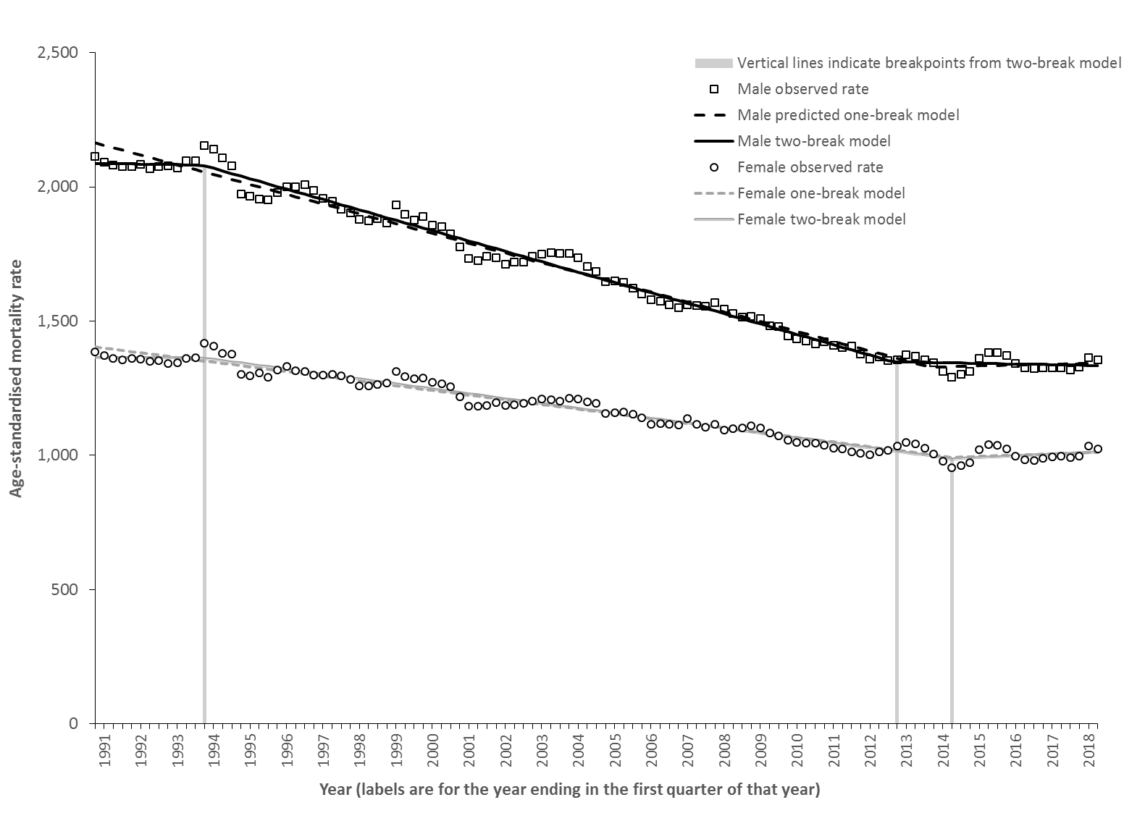

**Figure 5 – One and two breakpoint estimates for age-standardised mortality rate trends (1990-2018) for males and females in Scotland (dots provide point estimates and lines the 95% confidence intervals)**

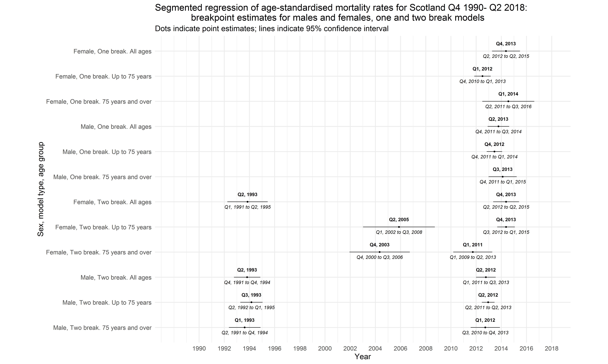

**Discussion**

**Main results**

Life expectancy in Scotland has generally increased since 1855 for males and females, but have increased at different rates over time. The annualised rate of increase was greatest between 1892 and 1956, albeit with large declines in 1897-1901 and 1937-1941 for men, with smaller and steadier increases from 1957 onwards. Between 2012 and 2016 the increases were only 2.5 weeks/year for women and 4.5 weeks for men. Of 13 high income countries, only England & Wales and the USA saw smaller increases than Scotland over this time period. The rate of increase was highly variable across countries, with several countries experiencing markedly lower increases than in previous time periods (notably the USA, England & Wales, Scotland and the Netherlands) and several with similar (Poland, Denmark, Czech Republic) or even greater (Japan and Belarus) than in 1997-2011. For all ages, the two break model estimates that the recent mortality trends in Scotland changed from their previous trends for men in the year to Q2 2012 and for women in the year to Q4 2013. For all the models the turning points were consistently identified between 2011 and 2015.

**Strengths and limitations**

Using life expectancy and age-standardised mortality rates ensures that the analyses in this paper are not prone to confounding by changes in the age structure of the population. We also use all-cause mortality rates which avoids difficulties due to competing causes of death and coding uncertainties. All of the analyses use longer time series to avoid over-interpretation of year-to-year fluctuations. We have also performed sensitivity analyses on the periodisation of the international comparisons to identify the potential for the findings to be simply due to the selection of a particular start date for the analyses.

The main limitation of this analysis is the range of countries included in the international comparison, which is due to the availability of data through the HMD at the time of analysis. We also only had access to within-year mortality data for Scotland which meant that the segmented regression analysis could only be done for this population.

**How this fits**

The recent stalled improvement of life expectancy trends across many high income countries is now well recognised.5-6789101112 The turning point in the mortality trends occurred at a similar time in Scotland to those in England for the total population, but slightly later than in England when the data are age-stratified.7 Various hypotheses have been proposed to explain these trends, but in particular influenza and austerity.

Some of the influenza surveillance systems detected large increases in crude mortality during the first half of 2015, and in the first few months of 2017 and 2018.10 [19] Cause-specific mortality rates for influenza and respiratory conditions were also responsible for part of the increases in mortality rates during this time period. The surveillance data for influenza-like illness (ILI) collected through healthcare systems and laboratory testing did not consistently indicate particularly substantial influenza seasons10 19 and the extended period over which mortality rates remained high make influenza less likely to be an important explanation across all countries and time periods.

It is possible that influenza and political economy explanations are both causal, perhaps with influenza as a biological mechanism linking such exposures to mortality. An important exposure is the financial crisis which spread across the world in 2008 which led to a marked economic recession in many countries. Given that unemployment and income are important determinants of health,[20] the potential for the crisis to adversely impact on mortality was highlighted early.[21] However, the evidence around the impact of economic recession on health and mortality of populations, rather than individuals, is complex and contested.[22]

The response to the financial crises from 2008 across many countries was to implement a range of austerity policies whereby public spending was reduced in the pursuit of balanced budgets or even budgetary surpluses. Where money was created, as with the quantitative easing policies in the USA and UK, this was generally used to refinance the banks rather than to protect public services. As a result, a very wide range of public services experienced substantial reductions in their budgets and public sector wages and income transfers to lower income groups were frequently reduced in real terms. There is evidence that this impacted on a range of health outcomes, but not always consistently or negatively.[23]-[24][25][26][27]

A particular aspect of austerity in the UK has been the very substantial reductions in budget available to local government. This impacts on a wide range of services, but a particular proposed mechanism has been through reduction in the budget available to provide social care services, something that is largely delivered to the elderly either living at home or in residential accommodation.9 [28] [29] It has been suggested that this meant that fewer people could be adequately cared for outside of the NHS, leading to lower quality care and increased demand on hospital services. Areas with the largest reductions in spending in England had the greatest mortality increases.[30] It has also been proposed that the increased segregation of society, associated with rising income inequality, has also contributed to social isolation and loneliness that has exacerbated the impact of service reductions.[31]

Another specific aspect of austerity in several countries has been changes to social security to reduce the real-terms value of benefits, reduce their coverage and eligibility, and to increase the range of conditions placed on their receipt. In the UK it was proposed that this would impact most on working-age adults, although child poverty has also seen marked rises and many of the proposed changes have yet to have fully worked through with large rises in income inequality and poverty projected for the future.[32] There is some ecological evidence that this has negatively impacted on some aspects of health in Scotland, including mortality rates for those aged 50-74 years.9

Other hypotheses have also been proposed. During the rise in obesity in most high income countries, epidemiologists warned that this might result in increases in a range of conditions such as Type II diabetes, osteoarthritis and cancer, and through these mechanisms, mortality.[33] Another factor that may be relevant is the increases in the age at which people are entitled to pensions, perhaps by putting the population reaching the previous retirement age in the position of having to work longer than would otherwise have been the case. This could operate through various mechanisms: lower incomes; the impact on biology of working at an older age; or through the diversion from caring duties, family support or volunteering towards paid work. Pensioner poverty rates and the value of social security payments for pensions are also likely to be important.30 [34]

**Implications**

Further descriptive work on the contribution of different causes of death, age-specific components and inequalities in the trends in Scotland requires further analyses. Work to understand the theoretical interaction of different hypothesised causes of the recent trends, and to test these theories is urgently required. In the meantime, governments at all levels should seek to provide public services according to need and sufficient social protection for all of their populations as key determinants of health. Providing effective vaccination programmes against influenza and sufficient health and social care capacity to deal with surges in demand is also required.

**Conclusion**

Between 2012 and 2016 the rate of improvement in mortality markedly slowed across many high income countries, and particularly in England & Wales, the USA, Scotland and the Netherlands. For this period in Scotland, the increases were only 2.5 weeks/year for women and 4.5 weeks for men. The change in mortality trend in Scotland for all ages is best estimated for men in the year to Q2 2012 and for women in the year to Q4 2013. For all the models the turning points were consistently identified between 2011 and 2015. Further research is required to test the range of theories for the causes of these trends, but in the meantime governments should take action to ensure effective public services, incomes, health and social care services and influenza vaccination programmes are in place.

**Competing interests**

The authors declare that they have no competing interests. No funding was received for this work.

**Funding**

No funding was received for this work. GM, LF and JM are salaried by the NHS, and JR and MK are salaried by NRS.

**Contributor statement**

GM drafted the manuscript. LF and JM undertook the analyses. All authors made substantial contributions to editing the manuscript and approved the final draft.

**References**

1. McCartney G, Walsh D, Whyte B, Collins C. Has Scotland always been the ‘sick man’ of Europe? European Journal of Public Health 2012; 22(6): 756–760.
2. Minton J, Vanderbloemen L, Dorling D. Visualizing Europe’s demographic scars with coplots and contour plots. International Journal of Epidemiology 2013; 42(4): 1164–1176, <https://doi.org/10.1093/ije/dyt115>.
3. Leon, DA. Trends in European life expectancy: a salutary view. International Journal of Epidemiology 2011; 40(2): 271–277, <https://doi.org/10.1093/ije/dyr061>.
4. Minton J, Shaw R, Green M, Vanderbloemen L, Popham F, McCartney G. Visualising and quantifying ‘excess deaths’ in Scotland compared with the rest of the UK and the rest of Western Europe. J Epidemiology and Community Health 2017; 71: 461-467, doi: 10.1136/jech-2016-207379.
5. Ho JY, Hendi AS. Recent trends in life expectancy across high income countries: retrospective observational study. BMJ 2018; 362: k2562, <http://dx.doi.org/10.1136/bmj.k2562>.
6. Changing trends in mortality: an international comparison: 2000 to 2016. Analysis of period life expectancies and mortality in selected countries globally from 2000 to 2016. London, Office for National Statistics, 2018.
7. Changing trends in mortality: a cross-UK comparison, 1981 to 2016. Analysis of age-specific and age-standardised mortality rates for the UK, England, Wales, Scotland and Northern Ireland from 1981 to 2016. London, Office for National Statistics, 2018.
8. Woolf SH, Chapman DA, Buchanich JM, Bobby KJ, Zimmerman EB, Blackburn SM. Changes in midlife death rates across racial and ethnic groups in the United States: systematic analysis of vital statistics. BMJ 2018; 362: k3096, <http://dx.doi.org/10.1136/bmj.k3096>.
9. Taulbut M, Agbato D, McCartney G. Working and hurting? Monitoring the health and health inequalities impacts of the economic downturn and changes to the social security system. Glasgow, NHS Health Scotland, 2018.
10. Vestergaard LS, Jens Nielsen J, Tyra G Krause TG, et al. Excess all-cause and influenza-attributable mortality in Europe, December 2016 to February 2017. Eurosurveillance 2017; 22(14), <https://doi.org/10.2807/1560-7917.ES.2017.22.14.30506>.
11. Bradford-Hill A. The Environment and Disease: Association or Causation? Proceedings of the Royal Society of Medicine 1965; 58(5): 295–300.
12. Parkinson J, Minton J, Lewsey J, Bouttell J, McCartney G. Recent cohort effects in suicide in Scotland: a legacy of the 1980s? J Epidemiology and Community Health 2017; 71: 194-200.
13. Parkinson P, Minton M, Lewsey J, Bouttell J, McCartney G. Drug-related deaths in Scotland 1979–2013: evidence of a vulnerable cohort of young men living in deprived areas. BMC Public Health (2018) 18:357, https://doi.org/10.1186/s12889-018-5267-2.
14. Minton J, Shaw R, Green M, Vanderbloemen L, Popham F, McCartney G. Visualising and quantifying ‘excess deaths’ in Scotland compared with the rest of the UK and the rest of Western Europe. J Epidemiology and Community Health 2017; 71: 461-467, doi: 10.1136/jech-2016-207379.
15. McCartney G, Bouttell J, Craig N, Craig P, Graham L, Lakha F, Lewsey J, McAdams R, MacPherson M, Minton J, Parkinson J, Robinson M, Shipton D, Taulbut M, Walsh D, Beeston C. Explaining trends in alcohol-related harms in Scotland, 1991-2011 (I): the role of incomes, effects of socio-economic and political adversity and demographic change. Public Health 2016; 132: 13-23.
16. Benchimol EI, Smeeth L, Guttmann A, Harron K, Moher D, Petersen I, et al. The REporting of studies Conducted using Observational Routinely-collected health Data (RECORD) Statement. PLoS Med 2015; 12(10): e10018.
17. Human Mortality Database. University of California, Berkeley (USA), and Max Planck Institute for Demographic Research (Germany). Available at www.mortality.org or www.humanmortality.de (data downloaded on [date]). – JM: I can’t give download date as this analysis was done by Lynda.
18. Muggeo VMR. segmented: An R Package to Fit Regression Models with Broken-Line Relationships. R news 2008; 8(1): 20-25.
19. Mølbak K, Espenhain L, Nielsen J. Excess mortality among the elderly in European countries, December 2014 to February 2015. Euro Surveill. 2015; 20(11), <https://doi.org/10.2807/1560-7917.ES2015.20.11.21065>.
20. Roelfs DJ, Shor E, Davidson KW, Schwartz JE. Losing life and livelihood: a systematic review and meta-analysis of unemployment and all-cause mortality. Social Science Medicine 2011; 72(6): 840-54, doi: 10.1016/j.socscimed.2011.01.005.
21. Marmot MG, Bell R. How will the financial crisis affect health? BMJ 2009; 338: b1314, doi: <https://doi.org/10.1136/bmj.b1314>.
22. Tapia Granados JA, Ionides EL. Population health and the economy: Mortality and the Great Recession in Europe. Health Economics 2017; 26:e219–e235.
23. Parmar D, Stavropoulou C, Ioannidis JPA. Health outcomes during the 2008 financial crisis in Europe: systematic literature review. BMJ 2016; 354, i4588, doi: <https://doi.org/10.1136/bmj.i4588>.
24. Margerison-Zilko C, Goldman-Mellor S, Falconi A, Downing J. Health impacts of the Great Recession: a critical review. Current Epidemiological Reports 2016; 3(1): 81-91.
25. Modrek, S, Stuckler D, McKee M, Cullen MR, Basu S. A review of health consequences of recessinos internationally and a synthesis of the US response during the Great Recession. Public Health Reviews 2013; 35(1), <https://doi.org/10.1007/BF03391695>.
26. Van Gool K, Pearson M. Health, austerity and economic crisis. Assessing the short=term impact in OECD countries. Paris, OECD publishing, 2014.
27. Karanikolos M, Mladovsky P, Cylus J, et al. Financial crisis, austerity, and health in Europe. Lancet 2013; 381: 1323-1331.
28. Hiam L, Dorling D, McKee M. The cuts and poor health: when and how can we say that one thing causes another? Journal of the Royal Society of Medicine; 2018, Vol. 111(6) 199–202, doi: 10.1177/0141076818779237.
29. Watkins J, Wulaningsih W, Da Zhou C, et al Effects of health and social care spending constraints on mortality in England: a time trend analysis BMJ Open 2017;7:e017722. doi: 10.1136/bmjopen-2017-017722.
30. Loopstra R, Reeves A, Barr B, Taylor-Robinson D, McKee M, Stuckler D. The impact of economic downturns and budget cuts on homelessness claim rates across 323 local authorities in England, 2004–12. Journal of Public Health; 38(3): 417–425, doi:10.1093/pubmed/fdv126.
31. Dorling D. Dying Quietly: English Suburbs and the Stiff Upper Lip. The Political Quarterly [online first].
32. Hood A, Waters T. Living standards, poverty and inequality in the UK: 2016–17 to 2021–22. London, Institute for Fiscal Studies, 2017.
33. Olshanksy SJ, Passaro DJ, Hershow RC. A Potential Decline in Life Expectancy in the United States in the 21st Century. N Engl J Med 2005; 352:1138-1145, doi: 10.1056/NEJMsr043743.
34. Fransham M, Dorling D. Have mortality improvements stalled in England? Same data—different stories. BMJ 2017; 357: j1946, doi: 10.1136/bmj.j1946.